Press Release

CHED@22: SUSTAINING AND ADVANCING THE GAINS
Excellent HEIs and academic programs recognized
May 18, 2016, Quezon City – In celebration of the Commission on Higher Education’s 22nd Founding Anniversary, two events were held to recognize exceptional and high performing higher education institutions (HEIs) and academic programs.
Autonomous and Deregulated status were conferred on 75 private HEIs nationwide. To achieve this distinction, institutions should have an established track record of exceptional program performance and institutional quality, demonstrated mature internal quality assurance systems as shown in their high proportion of accredited programs, garnered Centers of Excellence and Centers of Development, attained international accreditation and certification, among others.
CHED Chairperson Patricia B. Licuanan underscored that “the long-term goal is to have a critical mass of Autonomous and Deregulated HEIs that have established their internal quality assurance systems and are capable of self-regulation.” The 75 HEIs represent 4% of the total 1,708 private institutions in the country. The target is to reach at least 10%. The CHED Chair also urged HEI officials to use the benefits of their status “wisely and well” and to aspire and work for constant improvement, which is a sign of maturity and quality.
Centers of Excellence (CoEs) and Centers of Development (CoDs) were awarded in various disciplines. A total of 432 Centers nationwide were recognized, 199 Centers of Excellence and 233 Centers of Development from 139 HEIs.
Center of Excellence is a distinction granted by CHED to an institution which demonstrates exemplary performance in its teaching, research and extension function, while, Center of Development is granted to an institution with the potential to provide excellent education as evidenced by above average performance in the three areas.
The CHED Chair stressed that the CoEs and CoDs are an inherent mandate of the Commission, “They are envisioned to become centers of graduate education and research in their field of strength. Recently, these Centers have been identified as delivering institutions to support faculty development for the K-12 transition.”
Autonomous and Deregulated status and recognition as Centers of Excellence and Centers of Development are accompanied by certain privileges and support from CHED.
Each year, in observation of CHED’s anniversary, a week-long celebration dubbed as “Higher Education Week” features an exhibit of products and innovations from State Universities and Colleges nationwide.
This year’s theme is “CHED@22: Sustaining and Advancing the Gains.” CHED Chair Licuanan emphasized that the Commission has accomplished much over the years particularly under the Higher Education Reform Agenda of the Aquino administration focusing on the key result areas of Access, Capacity, Excellence and Ethical and Innovative Governance. “On our 22nd anniversary, we commit ourselves to sustaining and advancing these gains under the new Duterte administration,” she added.
CHED was created on May 18, 1994 by virtue of Republic Act No. 7722, otherwise known as the Higher Education Act of 1994.
#
PHOTOS AND CAPTIONS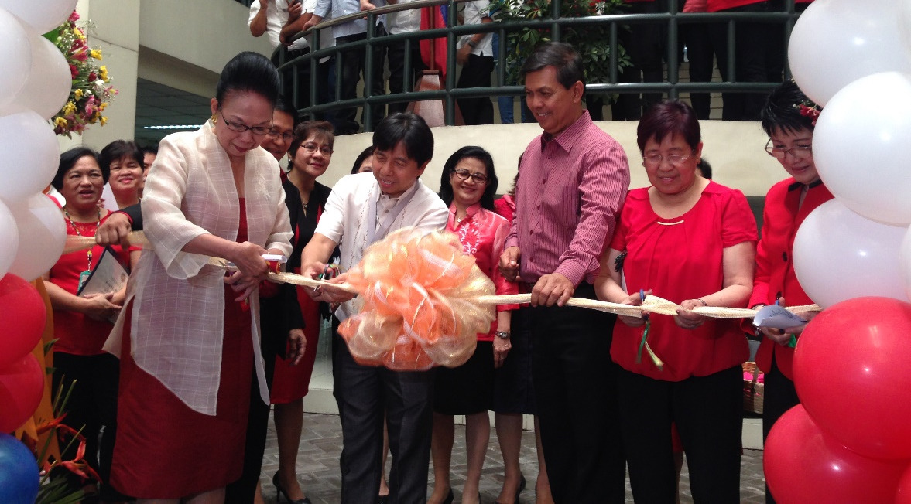
CHED@22 kicks off with a flag-raising ceremony and opening of the State Universities and Colleges Products and Innovations Fair. (L-R) CHED Chairperson Patricia B. Licuanan, CHED Commissioners Alex B. Brillantes, Ruperto S. Sangalang, Minella C. Alarcon and Maria Cynthia Rose B. Bautista.

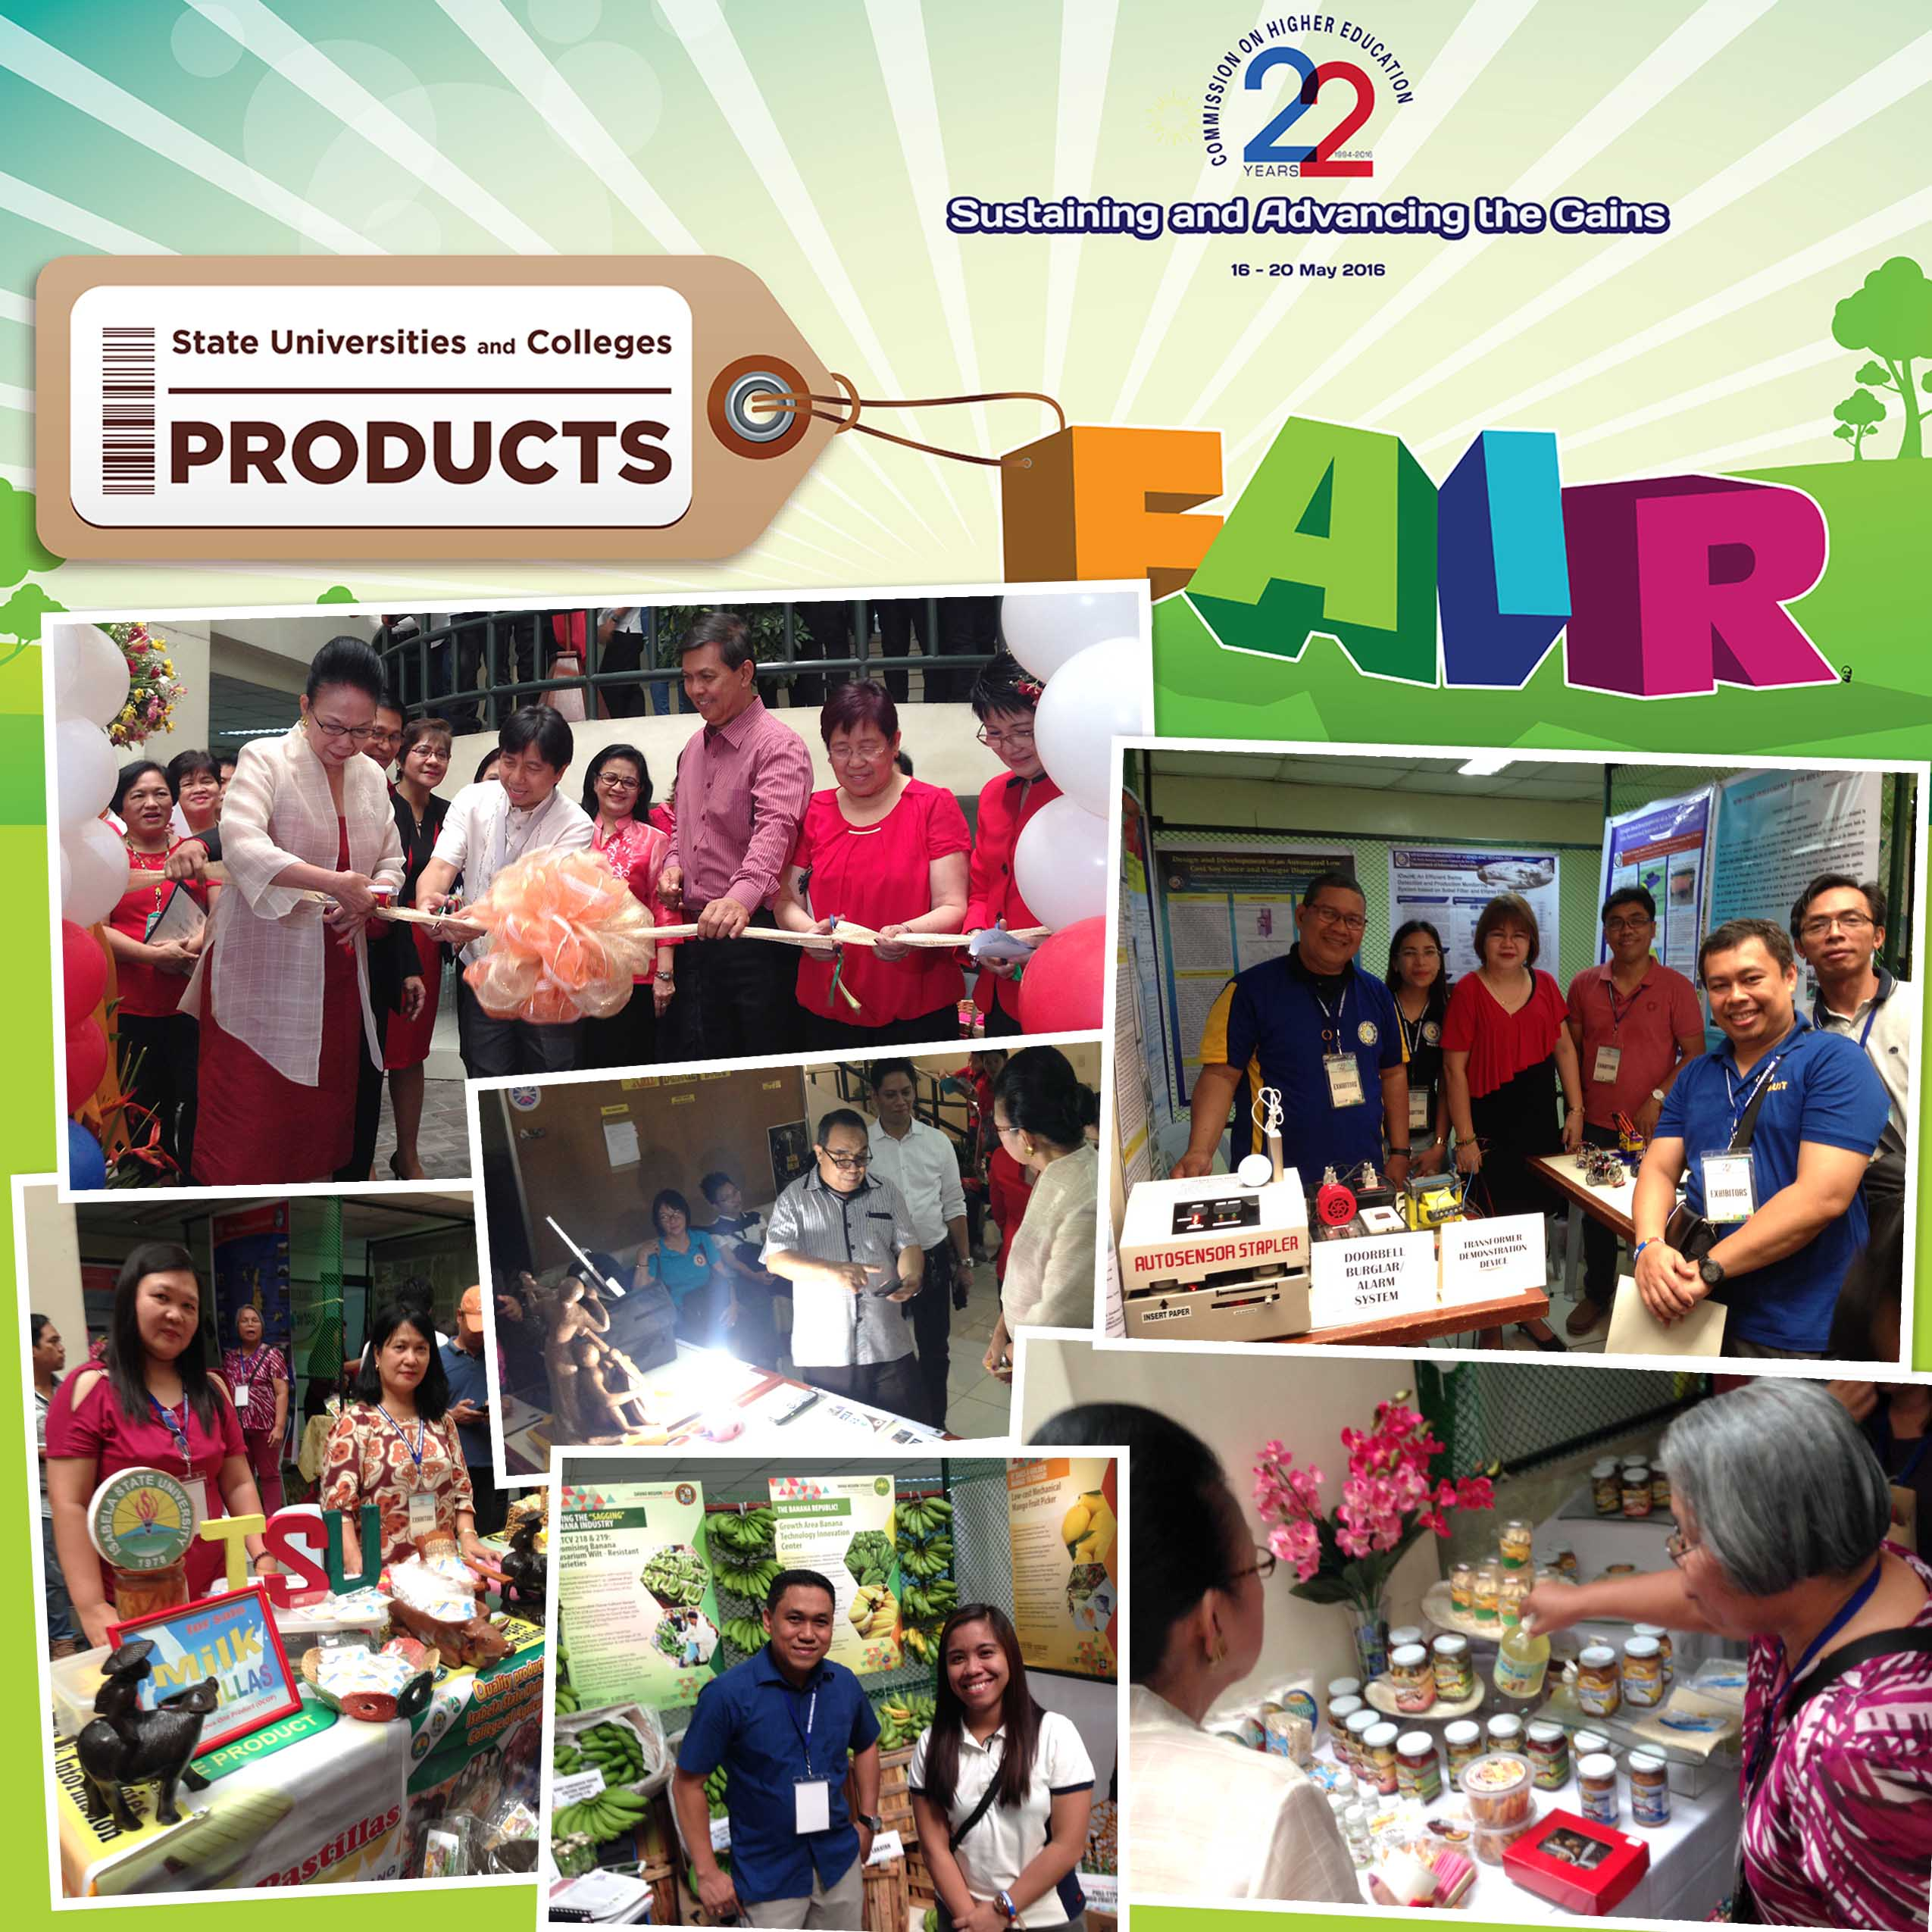
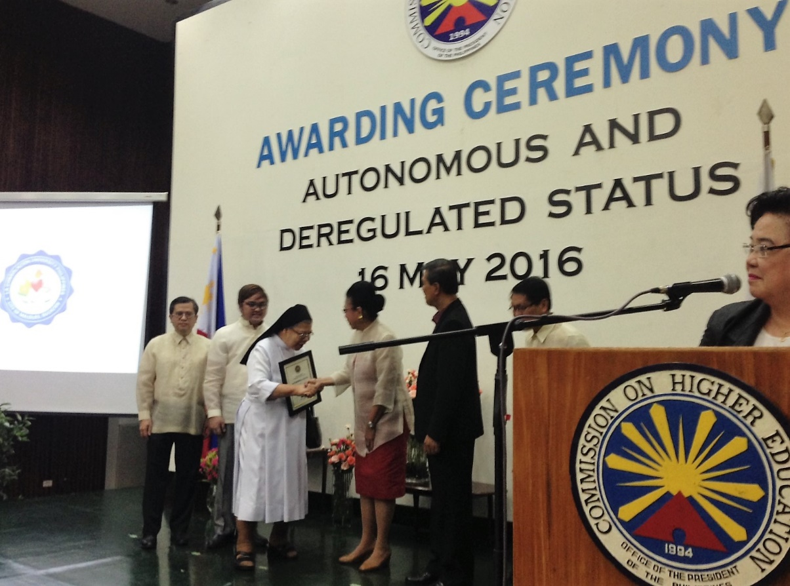
Autonomous and Deregulated status were conferred on 75 private higher education institutions nationwide in an awarding ceremony at the CHED Central Office Auditorium on May 16, 2016. #CHED@22

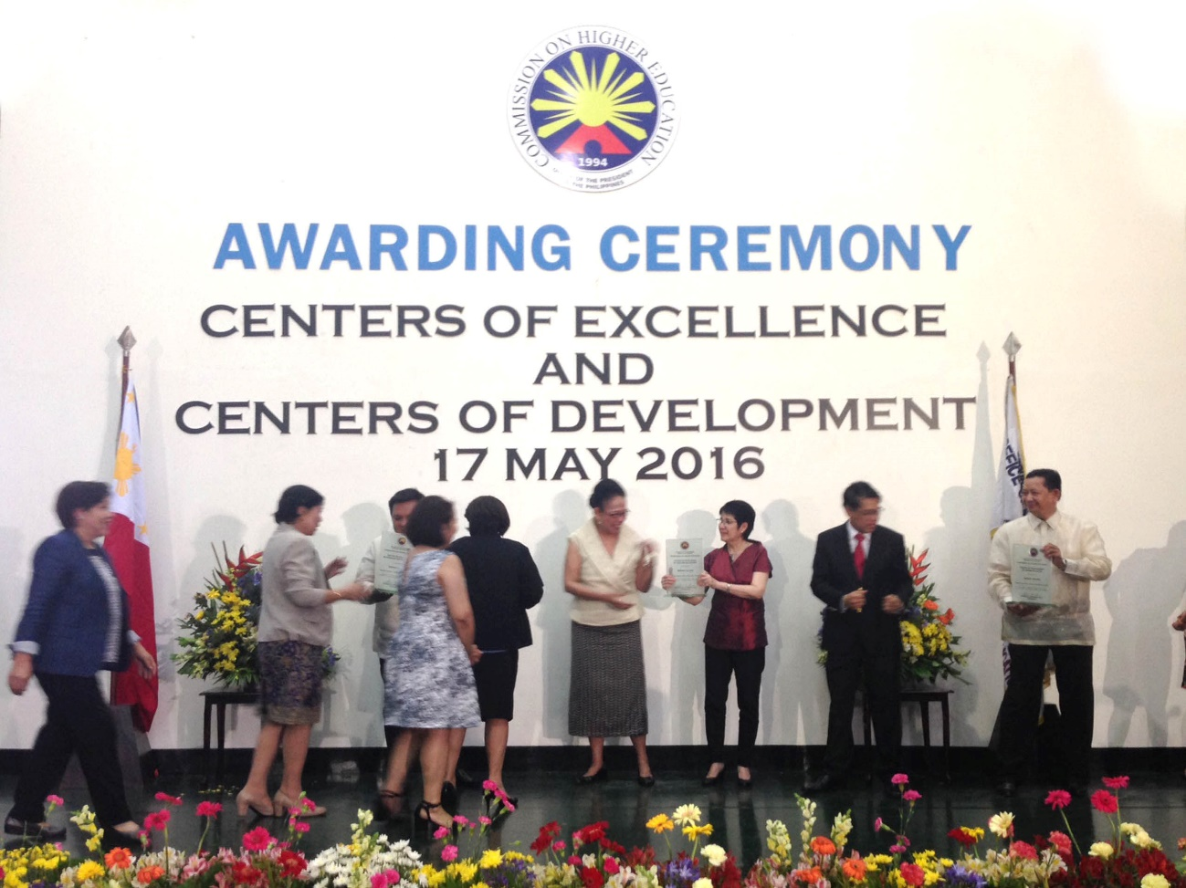
CHED awarded 432 Centers of Excellence and Centers of Development in various disciplines from 139 higher education institutions on May 17, 2016 at the CHED Auditorium. #CHED@22

